LAB REPORT实验报告
Lab Title | Operator Overloading in C++ |  |  |  | Lab No. | 13
Stud. Name | Jiang Yunxiang | Major | CST |  | Class
Student ID | 2022102330 |  | Date | 5/19
Lab description/objectives:
Write a C++ program to overload the + operator, to add two Time objects.
1. Define the Time class which should have three attributes of int data type: hour, minute, second, with 0 as their default value.
2. Define a member function showTime() to show the Time object as 11:45:33
3. Overload the + operator, to get the summation of two Time objects with the correct forms: hour(0-23), minute(0-59), second(0-59). For example, t1 is 1:50:30 , t2 is 2:15:25, then t1 + t2 will be 4:5:55

Source code:
（Paste the source code here）
#include<iostream>
using namespace std;

class Time {
public:
int hour, minute, second;
Time(int h = 0, int m = 0, int s = 0) :hour(h), minute(m), second(s) {}
void showTime() {
cout << hour << ":" << minute << ":" << second << endl;
}
Time operator+(Time& t2) {
int h = hour + t2.hour;
int m = minute + t2.minute;
int s = second + t2.second;
if (s >= 60) {
s -= 60;
m++;
}
if (m >= 60) {
m -= 60;
h++;
}
h = h % 24;
return Time(h, m, s);
}
};

int main()
{
Time t0(11, 45, 33);
Time t1(1, 50, 30);
Time t2(2, 15, 25);
Time t3 = t1 + t2;
t0.showTime();
t3.showTime();
return 0;
}
Program outputs:
（Paste the screenshot of program output here）
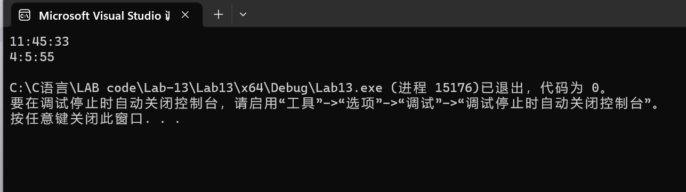
Discussion:
1．Most difficult parts
（What were the most difficult parts of your program to implement?）
Nope
2．Bugs and/or Errors
(List all the program bugs/errors you encountered and how you corrected them.)
Nope

